2024

Vipul Dessai

[Awesome Compony]

2/24/2024

DSA – Array

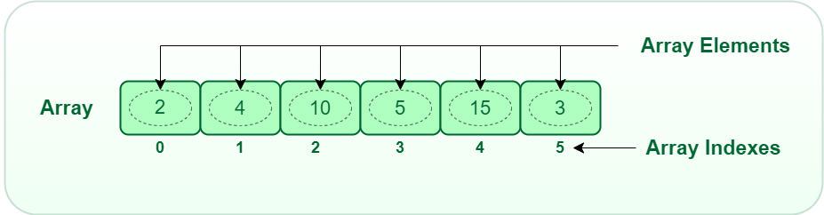

Contents

Insert Interval 2

Intuition 2

Complexity 2

Solution 2

Length of longest subarray with at most k frequency 2

Intuition 2

Complexity 2

# [Insert Interval](https://leetcode.com/problems/insert-interval/description/)

## Intuition

Find the min and the max in the overlapping range of the given intervals array

## Complexity

TC - O(N)

SC – O(N)

## [Solution](https://leetcode.com/problems/insert-interval/solutions/4889645/simple-array-merging-explaination/)

# [Length of longest subarray with at most k frequency](https://leetcode.com/problems/length-of-longest-subarray-with-at-most-k-frequency/description/)

## Intuition

Use the hash table to store frequency as the sliding window moves, use the right to add new item and left to remove the item

## Complexity

TC - O(N)

SC – O(N)

[Solution](https://leetcode.com/problems/length-of-longest-subarray-with-at-most-k-frequency/solutions/4939139/simple-hash-table-and-sliding-window-solution-explaination)